**AIR QUALITY ANALYSIS PREDICTION IN TAMILNADU**

**Team Members:**

**Jessica Margret Sathya .S -310821243022**

**Jebasta.J-310821243021**

**Gifta Sadha.J-310821243017**

**Muthulakshmi.M-310821243025**

**Air Quality Analysis Report Overview:**

1. Introduction:

- Brief overview of the purpose and scope of the report.

- Importance of air quality analysis for public health and environmental well-being.

2. Geographical Context:

- Description of Tamil Nadu's geography and its impact on air quality.

- Highlighting major cities, industrial areas, and potential pollution sources.

3. Data Sources and Methodology:

- Explanation of the data collection process and sources of air quality data.

- Methodological approach for data processing, cleaning, and analysis.

4. Historical Air Quality Trends:

- Analysis of air quality trends over the past decade.

- Focus on key pollutants (PM2.5, PM10, NO2, SO2, O3, CO) and their variations over time.

5. Current Air Quality Status:

- Present a snapshot of the current air quality across different regions of Tamil Nadu.

- Highlight any areas with particularly good or poor air quality.

6. Spatial Analysis:

- Examination of air quality variations across different districts or cities within Tamil Nadu.

- Identification of areas with high pollution levels and potential sources.

7. Temporal Analysis:

- Study of seasonal and temporal patterns in air quality.

- Analysis of factors contributing to variations in different seasons.

8. Source Apportionment:

- Identification of major sources of pollution contributing to poor air quality.

- Analysis of industrial, vehicular, and natural contributors.

9. Air Quality Prediction (Optional):

- Use of models to predict future air quality trends based on various scenarios.

- Forecasting potential improvements or deteriorations in air quality.

10. Policy Recommendations:

- Suggestions for policies and interventions to address specific air quality challenges in Tamil Nadu.

- Consideration of regulatory measures, emission control strategies, and public awareness campaigns.

11. Conclusion and Outlook:

- Summarize the key findings of the analysis.

- Provide an outlook on potential improvements in air quality and the importance of continued monitoring and intervention.

12. Appendices:

- Technical details, additional data, maps, and any supplementary information

**Air quality analysis:**

1. Data Collection: Gather air quality data from monitoring stations. This data typically includes measurements of various pollutants like PM2.5, PM10, NO2, SO2, O3, CO, and others.

2. Data Preprocessing: Clean and prepare the collected data. This involves tasks like handling missing values, removing outliers, and ensuring data consistency.

3. Exploratory Data Analysis (EDA): Analyze the data to understand its characteristics, trends, and relationships. Generate visualizations, summary statistics, and correlation matrices.

4. Statistical Analysis: Apply statistical techniques to quantify relationships between different variables and identify significant patterns.

5. Spatial Analysis: Consider the geographical distribution of monitoring stations. Analyze if there are any spatial patterns or clusters of pollution.

6. Temporal Analysis: Study the data over time to identify any seasonal or long-term trends in air quality. This can involve time series analysis.

7. Comparative Analysis: Compare air quality data across different regions or monitoring stations to identify variations and potential sources of pollution.

8. Source Apportionment: Use techniques like chemical mass balance or receptor modeling to identify major sources of pollution contributing to poor air quality.

9. Modeling (Optional): Utilize mathematical models to simulate and predict air quality based on various factors. This can help in forecasting future air quality.

10. Health Impact Assessment: Assess the potential health effects of the observed air quality levels on the population. This involves using established health risk assessment methodologies.

11. Policy Recommendations: Based on the analysis, provide recommendations for policies or interventions to improve air quality. This may include regulatory measures, emission control strategies, and public awareness campaigns.

12. Reporting and Visualization: Summarize the findings in a clear and accessible manner. Use charts, graphs, maps, and tables to present the analysis results.

13. Conclusion and Recommendations: Summarize the key findings, implications, and suggested actions based on the analysis.

**Python code:**

import pandas as pd

import matplotlib.pyplot as plt

import seaborn as sns

# Load your air quality data into a DataFrame (replace 'your_data.csv' with your data file)

data = pd.read_csv(r"C:\Users\saiganesh\Downloads\cpcb_dly_aq_tamil_nadu-2014.csv")

data

# Group the data by a specific region, such as 'City' or 'Area' based on your datagrouped_data = data.groupby('City/Town/Village/Area')

# Calculate average SO2, NO2, and RSPM/PM10 levels for each regionaverage_levels = grouped_data [['SO2', 'NO2', 'RSPM/PM10']]. mean ()

# Create a bar plot to visualize average SO2 levels by region

plt.figure(figsize=(12, 6))

sns.barplot(x=average_levels.index, y=average_levels['SO2'])

plt.title('Average SO2 Levels by Region')

plt.xticks(rotation=45)

plt.ylabel('Average SO2 Level')

plt.show()

# Create a bar plot to visualize average NO2 levels by region

plt.figure(figsize=(12, 6))

sns.barplot(x=average_levels.index, y=average_levels['NO2'])

plt.title('Average NO2 Levels by Region')

plt.xticks(rotation=45)

plt.ylabel('Average NO2 Level')

plt show()

# Create a bar plot to visualize average RSPM/PM10 levels by region

plt.figure(figsize=(12, 6))

sns.barplot(x=average_levels.index, y=average_levels['RSPM/PM10'])

plt.title('Average RSPM/PM10 Levels by Region')

plt.xticks(rotation=45)

plt.ylabel('Average RSPM/PM10 Level')

plt.show()

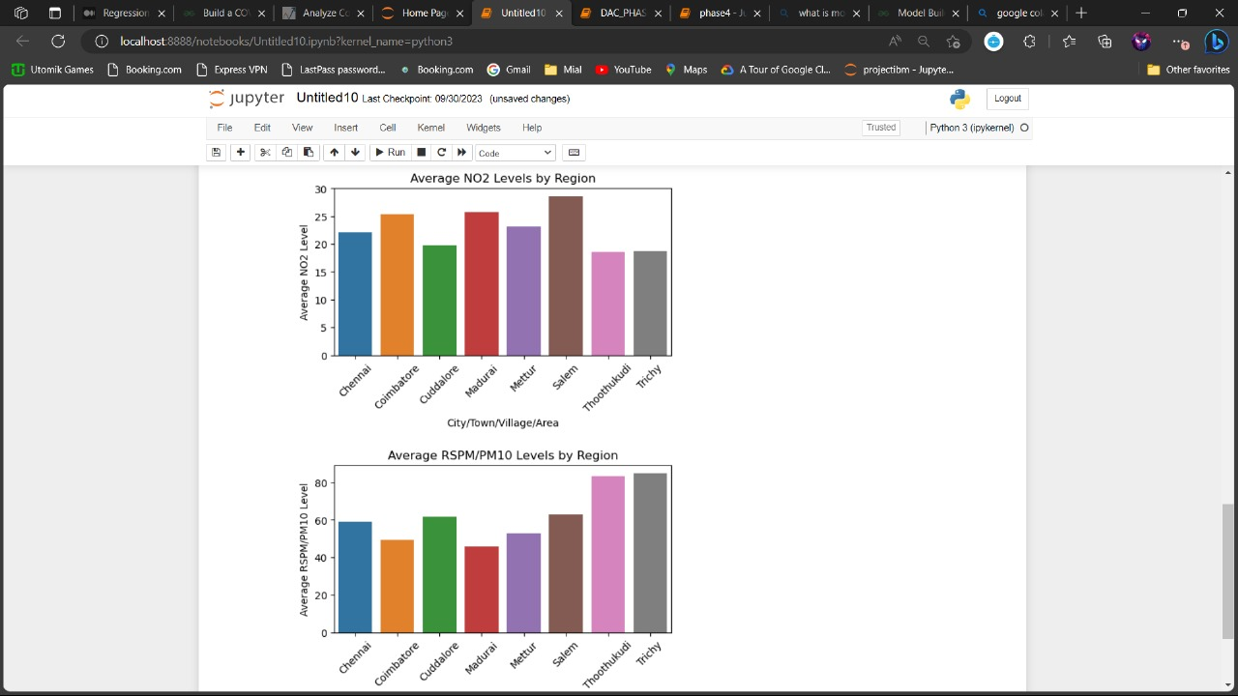

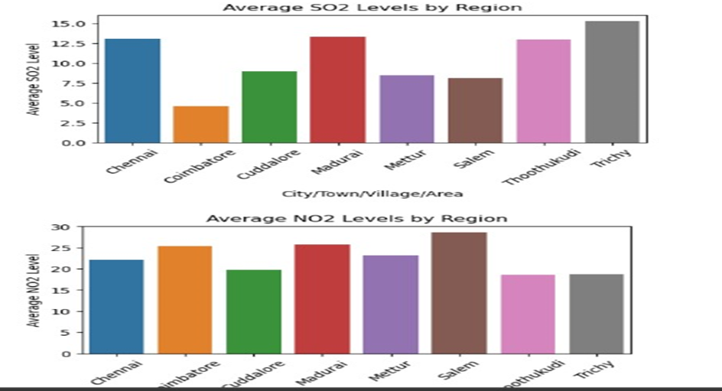

**Conclusion:**

An air quality analysis is a critical undertaking to assess and address environmental challenges. Through meticulous data collection, rigorous preprocessing, and comprehensive statistical analysis, we gain valuable insights into the state of air quality in a specific region, such as Tamil Nadu. Spatial and temporal assessments provide a nuanced understanding of pollution patterns, while source apportionment sheds light on the major contributors to poor air quality.

Additionally, modeling techniques can aid in predicting future trends, enabling proactive measures to safeguard public health and the environment. The findings from this analysis serve as a foundation for evidence-based policy recommendations. These may encompass regulatory measures, emission control strategies, and targeted interventions to mitigate pollution sources.

It is imperative to acknowledge that the efficacy of these recommendations is contingent on collaboration among stakeholders, including government bodies, industry players, and the public. Continued monitoring and assessment are vital to track progress and adapt strategies as needed. Overall, this air quality analysis provides a valuable framework for informed decision-making and underscores the significance of ongoing efforts to uphold clean and healthy air for all.